Website Content Updates

Overview
Below are two updates to content for the CSB Law website (https://www.csblawpdx.com/). Screenshots have been included to show the location of text to be altered. The text can be replaced in whole with the text provided below.
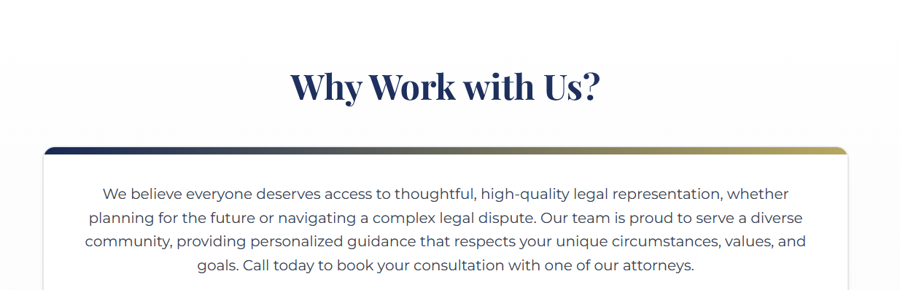

We believe everyone deserves access to thoughtful, high-quality legal representation, whether planning for the future or navigating a complex legal dispute. Our team at Carson Seegmuller & Baker LLP is proud to serve a diverse community, providing personalized guidance that respects your unique circumstances, values, and goals. Call today to book your consultation with one of our attorneys.
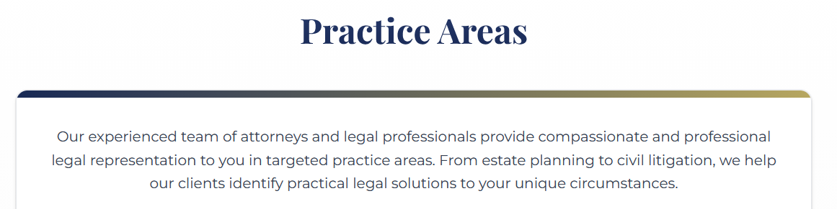

Our experienced team of attorneys and legal professionals provide compassionate and professional legal services and representation to you in targeted practice areas. From estate planning to civil litigation, we help our clients identify practical legal solutions to your unique circumstances.

